PASTOR LORENZ continues a period of study leave (thru Nov. 1). In his absence, pastoral needs and concerns may be directed to Rev. Bill Beck,
cell (717) 385-0703; to the Prayer Community through Rita Beck,
cell (717) 440-0304; or to the church office, (717) 243-4612.

SERVING TODAY:
Reader: Carlton Walker
Greeters/Ushers: Kari Kornish; Bruce & Anita Ashbaugh
Fellowship Hosts: Parish Life Committee
Video: Joe Shane
Audio: Ray Thomas

THIS WEEK, IN OUR PRAYERS:
* the church at work: Presbyteries of: Salem; Boston
* the church (Carlisle Presbytery): Wells Valley (Wells Tannery);
Becky Drover, Commissioned Ruling Elder
* the community: PA Council of Churches
* the congregation (at random): Bill, Ann, Julia & Kip Gottlieb;
Jean Thompson

THIS WEEK, IN THE LIFE OF THE CHURCH:
+ Monday, 2 PM: Faith Circle
+ Tuesday, 7 PM: Bible Study (via Zoom)
(Bible Study meets the 1st, 2nd & 4th Tuesdays of Oct. & Nov.)
+ Thursday, 7 PM: Choir rehearsal (NOTE change of day)
+ Saturday morning: Deacons serve breakfast at “Community Cares”

NEXT SUNDAY……………...23rd Sunday after Pentecost………..….October 31st
~ 9:15 AM: Prayer, in the sanctuary
~ 9:30 AM: Education hour; classes for all
~ 10:45 AM: Worship; Rev. Bill Beck preaching
~ After worship: Fellowship Time
(Note: Please sign up in Fellowship Hall if you wish to support
this Ministry of Hospitality.)

“MISSION MONTH” -- This year instead of Mission Sunday, the Board of Deacons is sponsoring MISSION MONTH, during which time we will support Community Cares of Cumberland County. During the remainder of October, we are asking for donations of toilet paper and paper towels. Collection boxes are inside the alley side entrance. Items should be in their original wrapper. The Board of Deacons will also purchase laundry detergent, disinfectant wipes, paper plates, and plastic utensils. These items will be used by Community Cares’ clientele, who wash 10-12 loads of laundry daily and receive meals daily (to 70). If you wish to support this project with a monetary donation, you may write a check to First Presbyterian Church,
noting “Deacons” on the memo line.
Thank you for your support of this local mission project!
Board of Deacons

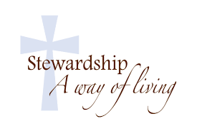
STEWARDSHIP 2022. In the coming days, you will receive stewardship materials in the mail. In addition to receiving the annual PW Thank Offering,
we will dedicate our 2022 commitments during worship on November 21.

Members of the Congregation, Ministers
The Rev. Anthony D. Lorenz, Pastor
The Rev. Jon A. Black, Pastor Emeritus
Debby Madden, Educator Emerita
Arthur Thompson, Organist; Ron Richcreek, Music Director
Avis Allen, Secretary; Chuck Adler, Sexton
Church Office Hours: Mon. & Wed., 9 AM-2 PM
Phone: (717) 243-4612; E-mail: fpcarl@pa.net;
Website: www.firstprescarlisle.org

First Presbyterian Church
On-the-Square
Carlisle, Pennsylvania

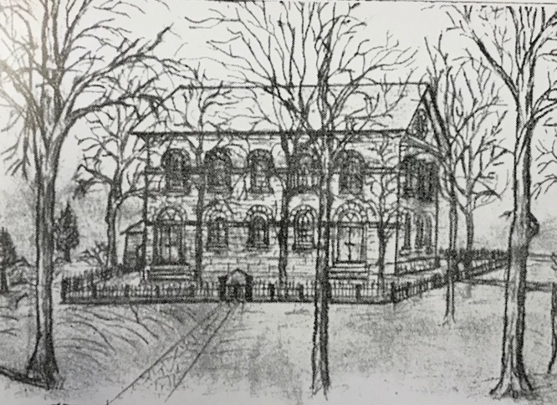

October 24, 2021
10:45 a.m.

The Twenty-Second Sunday
after Pentecost

ORDER FOR WORSHIP

GATHERING

PRELUDES
Blot ten Dag Ahnfelt
Gini Werea Baron ‘Sheir Scottish Melody
Duke Street Hopson

The Lord be with you. And also with you.
~ GREETING and ANNOUNCEMENTS ~

Prayer Gawthrop

* CALL TO WORSHIP

The earth is the Lord’s for God has made it.
Come let us worship God.

Praise the Lord in the beauty of God’s holiness..
Come let us worship God.

The mercy of the Lord is everlasting.
Come let us worship God.

Lord, open our lips,
And our mouths shall proclaim your praise and glory.

* HYMN #473 – “For the Beauty of the Earth”

* PRAYER OF CONFESSION

Almighty God, in raising Jesus from the grave,
you shattered the power of sin and death.
We confess that we remain captive to doubt and fear,
bound by the ways that lead to death.
We overlook the poor and hungry,
and pass by those who mourn;
we are deaf to the cries of the oppressed
and indifferent to calls for peace;
we despise the weak, and abuse the earth you made.
Forgive us, God of mercy.
Help us to trust your power
to change our lives and make us new. AMEN
(silent confession . . . .)

* ASSURANCE OF PARDON

* RESPONSE #74 (G) -- “Surely It Is God Who Saves Me”

Surely it is God who saves me;
I will trust in him and not be afraid.
For the Lord is my stronghold and my sure defense,
And he will be my Savior.

PROCLAIMING

PRAYER FOR ILLUMINATION

Eternal God,
in the reading of the Scripture,
may your Word be heard;
in the meditations of our hearts,
may your Word be known;
and in the faithfulness of our lives,
may your Word be shown. AMEN

FIRST LESSON Mark 10:46-52 (N.T., p. 47)
(The Word of the Lord; Thanks be to God!)

CHOIR ANTHEM “Built on a Rock” Althouse

SECOND LESSON Genesis 6:5-8, 12-22 (O.T., p. 5)
(The Word of the Lord; Thanks be to God!)

SERMON “Noah Had a Hammer” Debby Madden

* HYMN #357 – “O Master, Let Me Walk with Thee”

* THE APOSTLES’ CREED (traditional)

I believe in God the Father Almighty, Maker of heaven
and earth, and in Jesus Christ his only Son our Lord;
who was conceived by the Holy Ghost, born of the Virgin Mary,
suffered under Pontius Pilate, was crucified, dead,
and buried; he descended into hell; the third day he rose
again from the dead; he ascended into heaven, and sitteth
on the right hand of God the Father Almighty; from thence he
shall come to judge the quick and the dead. I believe in the
Holy Ghost; the holy catholic church; the communion of
saints; the forgiveness of sins; the resurrection of the body;
and the life everlasting. AMEN

PRAYERS OF THE PEOPLE AND LORD’S PRAYER (p. 16)

GIVING THANKS

OFFERING OURSELVES

PRAYER OF THANKSGIVING

Almighty God, giver of every good and perfect gift,
teach us to render to you all that we have
and all that we are, that we may praise you,
not with our lips only, but with our whole lives,
turning the duties, the sorrows, and the joys of all our days
into a living sacrifice to you, through our Savior, Jesus Christ.
AMEN

SENDING

* HYMN #386 -- “O for a World”

* BENEDICTION (Jeremiah 29:11-13)

* CLOSING RESPONSE – “God Be with You Till We Meet Again”

“God be with you till we meet again;
Loving counsels guide, uphold you,
With a Shepherd’s care enfold you;
God be with you till we meet again.”

* POSTLUDE Dix Sobaje

* * * * * * *
BOLD indicates Read Together
* indicates please stand, if able
(G) indicates use green songbook, “Sing! a new creation”

NOTE: Children & youth worship bulletins and packets
are available on the sanctuary windowsill. An usher can assist you.

WE THANK DEBBY MADDEN, our Educator Emerita, for leading
worship this morning.

AFTER WORSHIP TODAY, you are invited to remain for a time of
light refreshments and fellowship.

